-Nguyễn Minh Thành - 20521920

-Link drive

https://drive.google.com/drive/folders/1M7b-ZqltMhbpXMXsWtHHLOTKAz2ozHp6?usp=sharing

-Task 1 :

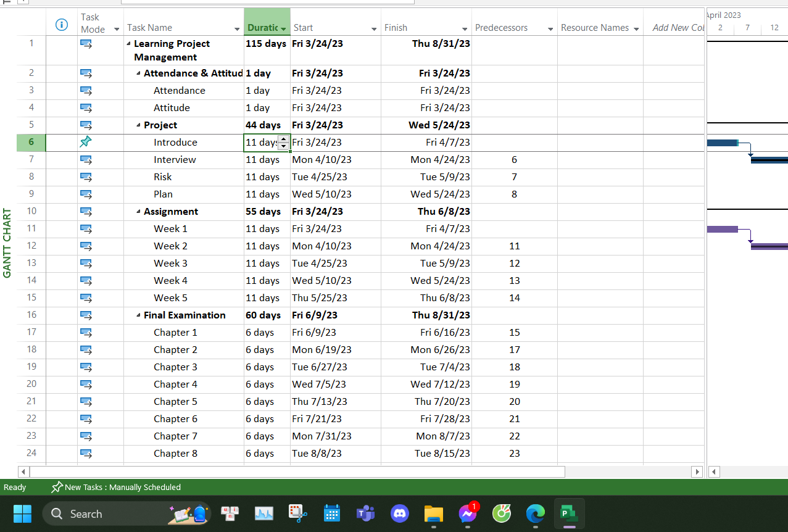

Task 2 :

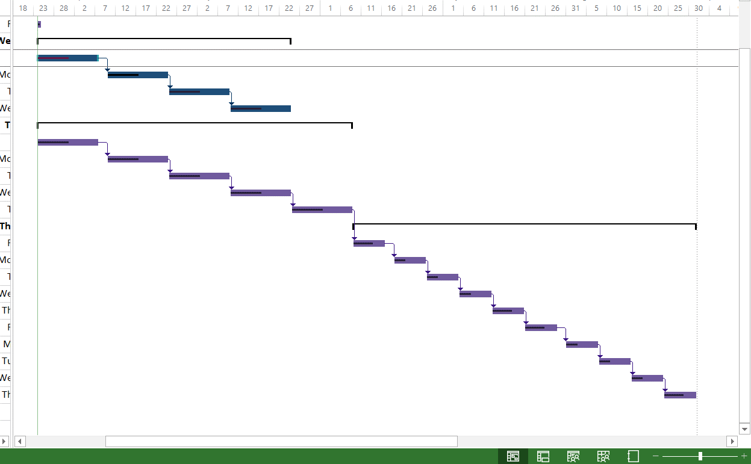

-Total 24/3

